|  |  |  |  |  |  |  |  |  |  |  |  |  |  |
| --- | --- | --- | --- | --- | --- | --- | --- | --- | --- | --- | --- | --- | --- |
| **Doc no.** | **Name** | **Address** | **Phone** | **Department**  **Id** | **Designation** | **Charges**  **Per hour** | **Patient**  **No.** | **Patient**  **Name** | **CNIC** | **Phone** | **Room**  **No.** | **Room**  **Type** | **Bed**  **No.** |
| **D1** | **Dr.Nadeem** | **Abc 123** | **0333-123,**  **042-123** | **Neurology** | **Professor** | **5000** | **P1** | **Kahlid** | **12345-1** | **042-1** | **R2** | **Normal** | **B1** |
| **P5** | **Ahmed** | **12345-2** | **042-2** |
| **P7** | **Anum** | **12345-3** | **042-3** | **Nill** |  | **Nill** |
| **D2** | **Dr.Nadeem** | **Kb13** | **0334-124,**  **0300-123** | **Orthopedic** | **Professor** | **5000** | **P4** | **Mehmood** | **12345-4** | **042-4** | **R2** | **Normal** | **B1** |
| **P7** | **Anum** | **12345-3** | **042-3** | **R4** | **Two bed** | **B5** |
| **P9** | **Khawar** | **12345-6** | **042-5** | **B7** |
| **D4** | **Dr.Erum** | **Ak123** | **0321-123** | **ENT/ Neurology** | **Astt. Professor** | **3000** | **P10** | **Tanweer** | **12345-7** | **042-6** | **Nill** |  | **Nill** |
| **P1** | **Khalid** | **12345-1** | **042-1** | **R5** | **Special** | **B8** |
| **D5** | **Dr.Hafeez** | **Nd123** | **0321-124** | **Skin/ Orthopedic** | **Astt. Professor** | **3000** | **P12** | **Sohail** | **12345-9** | **042-8** | **Nill** |  | **Nill** |
| **P13** | **Ahmed** | **12346-0** | **042-9** | **R6** | **Special** | **B9** |

At first Normal Form we remove the repeating groups (each row and column intersection have to have atomic value) and establish a primary key.

Remove Repeating group, Although Room No. and Bed No. are multivalued yet their groups are already removed i.e. Room Type=Special, Room No. 5,6,nil … Room Type. special Bed No. B5, B7

**1st Normal Form:**

**Removing Repeating groups and establishing Primary Key.**

Since,

DocNo, PatientNo 🡪Name, Address, Phone, Departmentid, Designation, ChargesPerHour, Patient Name, CNIC, Phone, Room No., Room Type,

Hence, It is more suitable candidate key to become primary key.

|  |  |  |  |  |  |  |  |  |  |  |  |  |  |
| --- | --- | --- | --- | --- | --- | --- | --- | --- | --- | --- | --- | --- | --- |
| **Doc no.** | **Name** | **Address** | **Phone** | **Department**  **Id** | **Designation** | **Charges**  **Per hour** | **Patient**  **No.** | **Patient**  **Name** | **CNIC** | **Phone** | **Room**  **No.** | **Room**  **Type** | **Bed**  **No.** |
| **D1** | **Dr.Nadeem** | **Abc 123** | **0333-123** | **Neurology** | **Professor** | **5000** | **P1** | **Kahlid** | **12345-1** | **042-1** | **R2** | **Normal** | **B1** |
| **D1** | **Dr.Nadeem** | **Abc 123** | **042-123** | **Neurology** | **Professor** | **5000** | **P1** | **Kahlid** | **12345-1** | **042-1** | **R2** | **Normal** | **B1** |
| **D1** | **Dr.Nadeem** | **Abc 123** | **0333-123** | **Neurology** | **Professor** | **5000** | **P5** | **Ahmed** | **12345-2** | **042-2** | **R2** | **Normal** | **B1** |
| **D1** | **Dr.Nadeem** | **Abc 123** | **042-123** | **Neurology** | **Professor** | **5000** | **P5** | **Ahmed** | **12345-2** | **042-2** | **R2** | **Normal** | **B1** |
| **D1** | **Dr.Nadeem** | **Abc 123** | **0333-123** | **Neurology** | **Professor** | **5000** | **P7** | **Anum** | **12345-3** | **042-3** | **Nill** |  | **Nill** |
| **D1** | **Dr.Nadeem** | **Abc 123** | **042-123** | **Neurology** | **Professor** | **5000** | **P7** | **Anum** | **12345-3** | **042-3** | **Nill** |  | **Nill** |
| **D2** | **Dr.Nadeem** | **Kb13** | **0334-124** | **Orthopedic** | **Professor** | **5000** | **P4** | **Mehmood** | **12345-4** | **042-4** | **R2** | **Normal** | **B1** |
| **D2** | **Dr.Nadeem** | **Kb13** | **0300-123** | **Orthopedic** | **Professor** | **5000** | **P4** | **Mehmood** | **12345-4** | **042-4** | **R2** | **Normal** | **B1** |
| **D2** | **Dr.Nadeem** | **Kb13** | **0334-124** | **Orthopedic** | **Professor** | **5000** | **P7** | **Anum** | **12345-3** | **042-3** | **R4** | **Two bed** | **B5** |
| **D2** | **Dr.Nadeem** | **Kb13** | **0300-123** | **Orthopedic** | **Professor** | **5000** | **P7** | **Anum** | **12345-3** | **042-3** | **R4** | **Two bed** | **B5** |
| **D2** | **Dr.Nadeem** | **Kb13** | **0334-124** | **Orthopedic** | **Professor** | **5000** | **P9** | **Khawar** | **12345-6** | **042-5** | **R4** | **Two bed** | **B7** |
| **D2** | **Dr.Nadeem** | **Kb13** | **0300-123** | **Orthopedic** | **Professor** | **5000** | **P9** | **Khawar** | **12345-6** | **042-5** | **R4** | **Two bed** | **B7** |
| **D4** | **Dr.Erum** | **Ak123** | **0321-123** | **ENT** | **Astt Professor** | **3000** | **P10** | **Tanweer** | **12345-7** | **042-6** | **Nill** |  | **Nill** |
| **D4** | **Dr.Erum** | **Ak123** | **0321-123** | **Neurology** | **Astt. Professor** | **3000** | **P10** | **Tanweer** | **12345-7** | **042-6** | **Nill** |  | **Nill** |
| **D4** | **Dr.Erum** | **Ak123** | **0321-123** | **ENT** | **Astt. Professor** | **3000** | **P1** | **Khalid** | **12345-1** | **042-1** | **R5** | **Special** | **B8** |
| **D4** | **Dr.Erum** | **Ak123** | **0321-123** | **Neurology** | **Astt. Professor** | **3000** | **P1** | **Khalid** | **12345-1** | **042-1** | **R5** | **Special** | **B8** |
| **D5** | **Dr.Hafeez** | **Nd123** | **0321-124** | **Skin** | **Astt. Professor** | **3000** | **P12** | **Sohail** | **12345-9** | **042-8** | **Nill** |  | **Nill** |
| **D5** | **Dr.Hafeez** | **Nd123** | **0321-124** | **Orthopedic** | **Astt. Professor** | **3000** | **P12** | **Sohail** | **12345-9** | **042-8** | **Nill** |  | **Nill** |
| **D5** | **Dr.Hafeez** | **Nd123** | **0321-124** | **Skin** | **Astt. Professor** | **3000** | **P13** | **Ahmed** | **12346-0** | **042-9** | **R6** | **Special** | **B9** |
| **D5** | **Dr.Hafeez** | **Nd123** | **0321-124** | **Orthopedic** | **Astt. Professor** | **3000** | **P13** | **Ahmed** | **12346-0** | **042-9** | **R6** | **Special** | **B9** |

Even we have removed all the repeating groups and established a primary key on the basis of our assumption, but still we have redundancies and anomalies (insertion, modification, deletion) in our relation.

If we have to admit a patient, it is mandatory to enter doctor No. as it is the part of primary key (insertion anomaly)

If we delete/ discharge any patient, or a doctor record may be deleted or updated in the relation, it should be updated in its all occurrences in the given relation, otherwise, data will be inconsistence (modification, deletion anomaly)

.

To resolve these anomalies we need to have an idea of Functional Dependencies:

A Functional Dependency among attribute or a set of attribute is a relation where the one instance of attribute or the set of attributes on the left-hand side of 🡪 determine one and exactly one occurrence of the attribute or set of attributes on the right-hand side.

Our relation contains Partial Functional Dependency:

Before Partial Functional Dependency we have to have an idea of Key attributes and Non-Key attribute:

An alternative name for Key attributes is Prime attributes and Non-key attributes is Non-Prime attributes.

Key Attributes: a single attribute or set of attributes that is part of candidate key, chosen as primary key during 1st NF.

Non-Key Attributes: a single or set of attributes that are not part of candidate key, chosen as primary key during 1st NF.

In our relation we have (DocNo, PatientNo) as Key attributes. And every other attribute is non-key.

Partial Dependency: A partial dependency occurs when in a given relation, one or more non-key attribute are functionally dependent on PART of key attributes.

What is part of key attributes ? In our relation we have DocNo, PatientNo as key attributes, now if we delineate this composite primary key, DocNo is one PART of this key and PatientNo is second.

**2nd Normal Form: All the relations in database must be in 1st Normal Form, and there will be No Partial Functional Dependencies in the relations.**

So, we deduce if some of the non-key attributes are dependent on only DocNo or only PatientNo. That would constitute partial dependency.

By looking at the relation we can assume that:

`

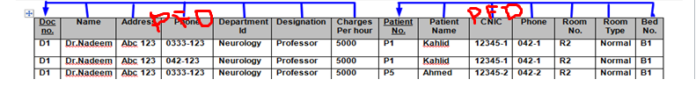

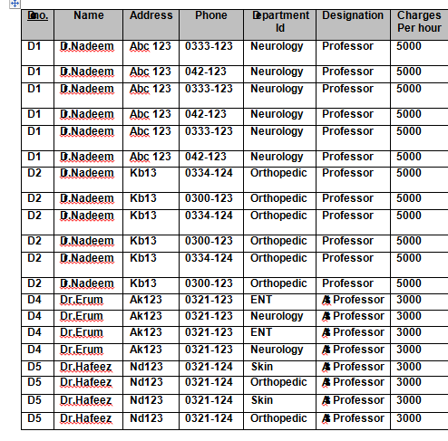

**Therefore, we can decompose two relations**

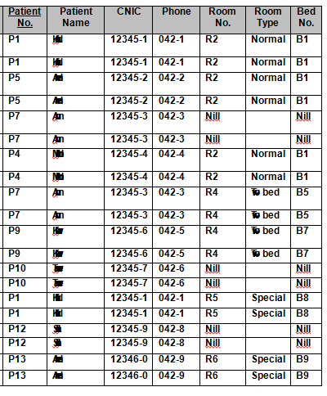

These two relations still have (insertion, modification, deletion) anomalies.

Transitive Dependency: A relation has transitive dependency if single or a set of non-key attribute transitively dependent on primary key through another non-key attribute.

**3rd Normal Form: All relation in a database must be in 2nd Normal Form i.e. there will be no PFD. In 3rd Normal Form we remove Transitive Dependencies.**

This relation has transitive dependencies.

DocNo 🡪Name, Address, Phone, Departmentid, Designation, ChargesPerHour

But, transitive dependency is

Designation 🡪 Charges Per Hour

And

DepartmentID 🡪 Designation

DocNo 🡪 Designation

DocNo 🡪 Designation

So, Charges Per Hour a non-key attribute is transitively dependent on DocNo through a non-key attribute designation

And Designation a non-key attribute is transitively dependent on DocNo through a non-key attribute DepartmentID

PatientNo🡪Patient Name, CNIC, Phone, Room No., Room Type, Bed No.

In same way,

RoomType 🡪 RoomNo

RoomType 🡪 BedNo

PatientNo 🡪 RoomType

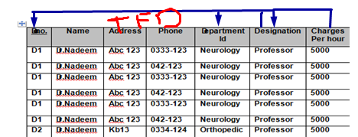

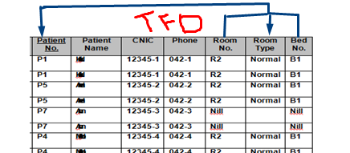

We decompose our relation by removing transitive dependencies.

|  |  |  |  |
| --- | --- | --- | --- |
| DocNo | Name | Address | Phone |

|  |  |
| --- | --- |
| Designation | Charges Per Hour |

|  |  |
| --- | --- |
| DepartmentID | Designation |

|  |  |  |  |
| --- | --- | --- | --- |
| PatientNo | Patient Name | CNIC | Phone |

|  |  |
| --- | --- |
| RoomType | Room No |

|  |  |
| --- | --- |
| Room Type | Bed No |

**BCNF – Boyce-Codd Normal Form also called 3.5 Normal Form: When all the relations are in 3rd Normal Form and any Non-key attribute determine primary key attribute.**

We, assume that CNIC 🡪 Patient No, we remove this functional dependency, and decompose patient relation further.

|  |  |  |
| --- | --- | --- |
| PatientNo | Patient Name | Phone |

|  |  |
| --- | --- |
| CNIC | PatientNo |

**4th Normal Form:**

**In 4th Normal all relations must be 3rd Normal Form and we remove multivalued attribute, repeating group attribute. So far, Phone in Doctor relation is multivalued, DepartmentID in Designation is multivalued, Room No and Bed No are multivalued. So our relation will be like:**

|  |  |  |
| --- | --- | --- |
| DocNo | Name | Address |

|  |  |
| --- | --- |
| DocNo | Phone |

|  |  |
| --- | --- |
| Designation | Charges Per Hour |

|  |
| --- |
| Designation |

|  |
| --- |
| DepartmentID |

|  |
| --- |
| RoomType |

|  |
| --- |
| Room No |

|  |
| --- |
| Bed No |

|  |  |
| --- | --- |
| PatientNo | Phone |

|  |  |
| --- | --- |
| CNIC | Patient Name |

**Once we are done with decomposing the relations we can build Primary Key – Foreign Key Relations along-with cardinality constraints.**

